**The relationship between *p*-values from TOST and SGPV when performing a correlation test**

Some applications:

* Testing discriminant validity (when evaluating two unrelated construct, equivalence test for correlation can be used in order to prove a lack of associations between scores ; Goertzen & Cribbie, 2010)
* Meta-analysis: as a proof that one can pool studies because of their similarities (Counsell & Cribbie, 2014).

## Case 1: showing that the correlation between two variables is equivalent to $ρ=0$ (absence of linear relation)

In the plot below *p*-values are calculated for the TOST equivalence testing procedure where a true population correlation ranging from -.4 to +.4 is compared to the test value of 0 in a correlation test for equivalence where equivalence bounds are set to difference of -.2 and +.2 around the test value of 0. In other words, the equivalence range contains all correlations between -.2 and +.2 (which is large, considering that a correlation of .3 is a medium correlation). Sample size equals 120. For ease of comparison, the SGPV is reverse (by calculating 1-SGPV).

Similar to what was observed for the comparison of means, p-value from the TOST procedure and the SGPV are very close (See Figure 1). However, there are substantial differences with the comparison of means:

* The sgpv overlaps the p-value from the equivalence procedure only in two points (when testing the equivalence of means both values overlapped in three points).
* The sgpv is not a straight line as when calculating CI around means (or means differences).

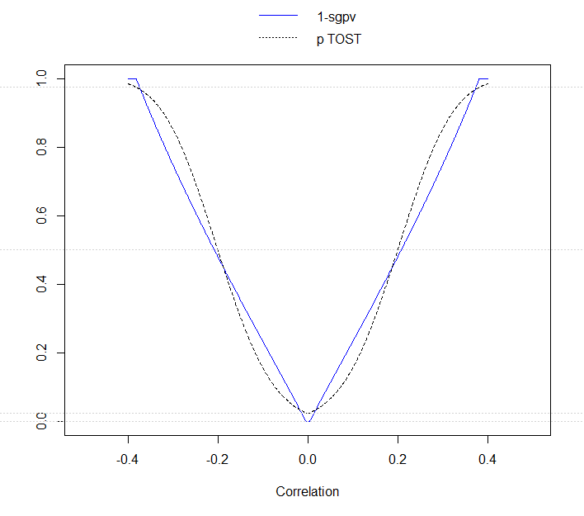

*Figure 1*: Comparison of *p*-values from TOST (dotted black line) and SGPV (blue line) across a range of values for correlations (from -.4 to +.4) tested against a value of 0 in equivalence test for correlation, with 120 subjects per group.

**Remark on Figure 1**: the range of correlations for which sgpv = 1 (or similarly, the range of correlations for which the TOST p-value < .025) is very narrow. Goertzen & Cribbie (2010) explain that equivalence test for correlations have very low power.

## Overlaps

* When the 95% CI falls completely, but only just inside the equivalence region, the SGPV equals 1 and the TOST p-value = .025
* When the 95% CI touches the outside of the equivalence bound, the SGPV equals 0 and the TOST p-value = .975.

When the observed correlation (=r) equals the equivalence bound, the TOST p-value exactly equals .5, thanks to the Fisher’s z transformation. Indeed, the Z value from equivalence is 0, and because Z follows a symmetric distribution (i.e. Z) the p-value is 0.5:

(1)

= 0 (2)

On the other side, the SGPV value does NOT equal .5 anymore, because the CI is NOT centered around the observed correlation.

As one can see on Figure 2, the CI is symmetric around the observed correlation in only one situation: when r = 0. When the observed correlation moves away for 0 the CI become positively skewed when r<0, and negatively skewed when r > 0.

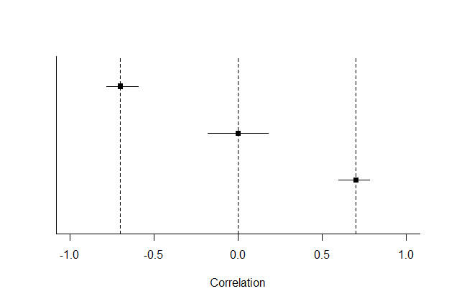

*Figure 2*: 1-2*alpha CI around an observed correlation ranging from 0 to .8 in steps of .4, with 120 subjects per group.

This can be explained by the way CI are constructed. In a first step, the r score of correlation is converted into z score, following the Fisher’s z transformation. In Figure 3, dots are marked on the red diagonal line when both scores are the same. There is the nonlinear relation between r and fisher’s z score in order that the further the correlation from 0, the largest the transformation impact (See Figure 3).

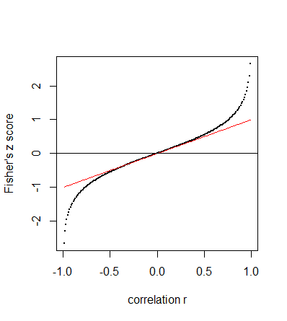

*Figure 3*: Fisher’s z score plotted against the correlation r.

In a second step, bounds around z are computed. Because the z distribution is normal, bounds are symmetrically computed around z. In a third step, z bounds are converted into r bounds. The relation between z and r is plotted in Figure 4. As in Figure 3, dots are marked on the red diagonal line when both scores are the same. The higher the z score, the larger the transformation. In other words, the bound that is further from 0 will decrease stronger than the bound that is closer of 0, which explains the asymmetry. When r is 0, the fisher z score also equals 0 and the lower and upper bounds around r are at equal distance from 0, meaning that they will be impact the exact same way by the transformation in the third step and therefore, the CI is not skewed).

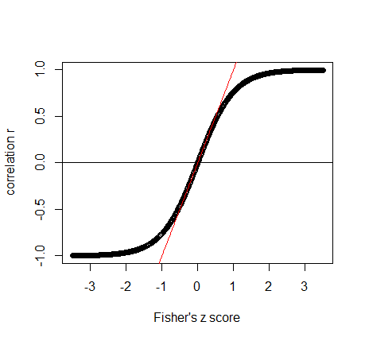

*Figure 4*: correlation plotted against the Fisher’s z score.

Because the main goal of the equivalence test is to show the absence of meaningful correlations between two variables, the equivalence bounds will not equal 0 (unless H0 is point H0), CI around the equivalences bounds will be skewed. As a consequence, the percentage of overlap with the equivalence range will therefore always be larger than the half CI, resulting in a value of SGPV larger than .5 (the SGPV is therefore slightly biased in favour of H0).

Because the further r from 0, the more skewed the confidence interval, it also has an implication on the fact that the difference in the percentage of overlap is not uniform across correlation differences.

## When are the SGPV and Equivalence test Unrelated

In the same way than when performing test comparing means:

* When the SGPV is 0 p-values from the equivalence test fall between .975 and 1 (excluded)
* When the SGPV is 1 p-values from the equivalence test fall between 0 (excluded) and .025
* When the SGPV is .5 because the CI is twice as wide as the equivalence range
* When the CI overlaps with the upper and lower equivalence bound, but the CI is not twice as wide as the equivalence range.

However, in this fourth situation, as previously mentioned, the observed correlation would be somewhat closer of 0, or further away from 0, the SGPV would not exactly remain constant (for reasons that were previously explained).

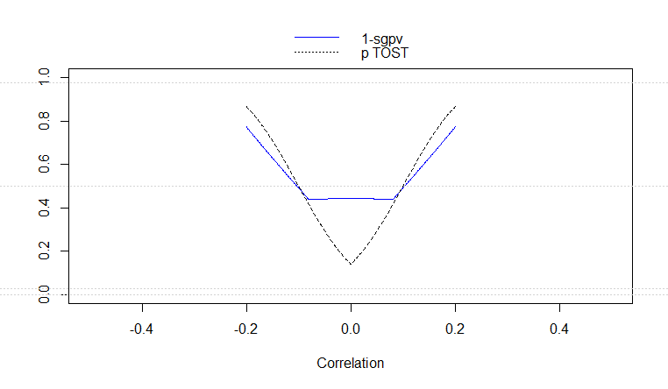

*Figure 5*: Comparison of *p*-values from TOST (dotted black line) and SGPV (blue line) across a range of values for correlations (from -.2 to +.2) tested against a value of 0 in equivalence test for correlation, with 120 subjects per group.

## Case 2: showing that the correlation between two variables is equivalent to a theoretical value $ρ≠0$

In the plot below *p*-values are calculated for the TOST equivalence testing procedure where a true population correlation ranging from .1 to .9 is compared to the test value of .5 in a correlation test for equivalence where equivalence bounds are set to difference of -.2 and +.2 around the test value of .5. In other words, the equivalence range contains all correlations between -.3 and +.7 (which is large, considering that a correlation of .5 is a large correlation and .3 is a medium correlation). Sample size equals 120. For ease of comparison, the SGPV is reverse (by calculating 1-SGPV).

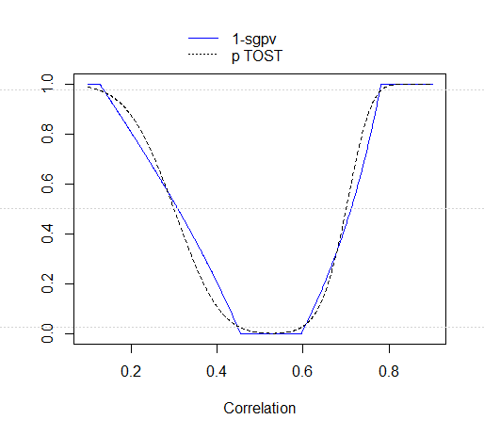

*Figure 6:* Comparison of *p*-values from TOST (dotted black line) and SGPV (blue line) across a range of values for correlations (from .1 to .9) tested against a value of .5 in equivalence test for correlation, with 120 subjects per group.

* As in case 1, the sgpv overlaps the p-value from the equivalence procedure only in two points
* As is case 1, the sgpv is not a straight line as when calculating CI around means (or means differences).
* Moreover, this time, for both TOST p-value and SGPV, there is no symmetry around the real population value (i.e. an observed correlation value of .3 will not return the same results than an observed correlation value of .7, even if both observed values are equally distant from the real population value).

## Overlaps

* When the 95% CI falls completely, but only just inside the equivalence region, the SGPV equals 1 and the TOST p-value = .025
* When the 95% CI touches the outside of the equivalence bound, the SGPV equals 0 and the TOST p-value = .975.

As in case 1, when the observed correlation (=r) equals the equivalence bound, the TOST p-value exactly equals .5, thanks to the Fisher’s z transformation. Indeed, the Z value from equivalence is 0, and because Z follows a symmetric distribution (i.e. Z) the p-value is 0.5:

(1)

= 0 (2)

On the other side, the SGPV value does NOT equal .5 anymore, because the CI is NOT centered around the observed correlation (this was explained beforehand).

Why both pvalues are not symmetrically distributed around the correlation of .5?

* About the SGPV, I think it is once again because the larger the observed correlation, the more skewed the CI.
* About the TOST p-value, when r > 0, the CI is left-skewed distributed (the interval width is larger left the observed correlation than right the observed correlation). When r > 0, the CI is left-skewed distributed (the interval width is larger left the observed correlation than right the observed correlation). The probability to obtain a nonsignificant result is then larger when the observed correlation is closer of the lower bound (i.e. .4) than when it is closer of the upper bound (i.e. .6).

## When are the SGPV and Equivalence test Unrelated

In the same way than in case 1:

* When the SGPV is 0 p-values from the equivalence test fall between .975 and 1 (excluded)
* When the SGPV is 1 p-values from the equivalence test fall between 0 (excluded) and .025
* When the SGPV is .5 because the CI is twice as wide as the equivalence range (see Figure 7, where the equivalence bounds are .5±.05)

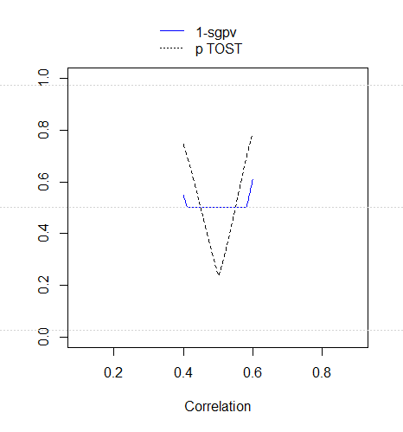

*Figure 7:* Comparison of *p*-values from TOST (dotted black line) and SGPV (blue line) across a range of values for correlations (from .4 to .6) tested against a value of .5 in equivalence test for correlation, with 120 subjects per group.

* When the CI overlaps with the upper and lower equivalence bound, but the CI is not twice as wide as the equivalence range (see Figure 8, where the equivalence bounds are .5 ±.1).

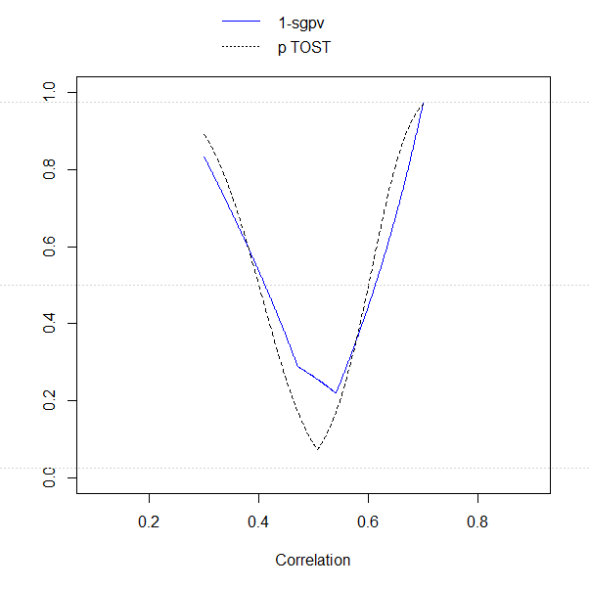

*Figure 8:* Comparison of *p*-values from TOST (dotted black line) and SGPV (blue line) across a range of values for correlations (from .3 to .7) tested against a value of .5 in equivalence test for correlation, with 120 subjects per group.